‘Faith i Branko’ Quartet (Serbia / UK) TECH SPEC / RIDER / GENERAL REQUIREMENTS

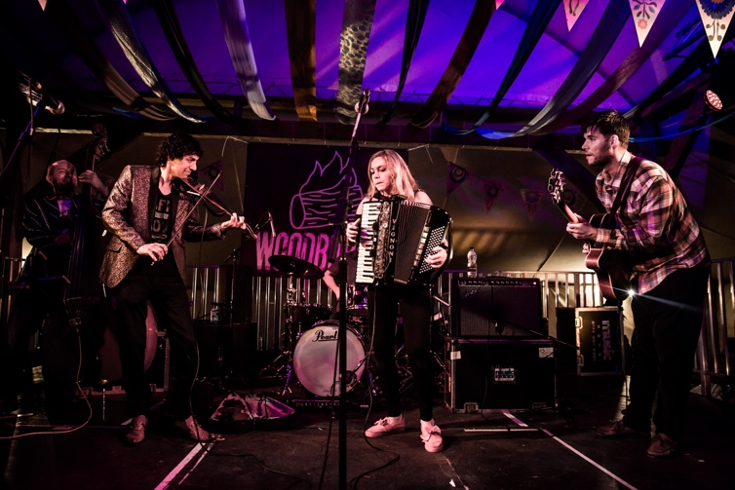

Contact Details

Website: www.faithibranko.com www.facebook.com/faithandbranko http://www.worldmusic.net/store/item/TUG1092

Band Contact: Faith Ristic (accordionist and manager)
UK Mobile / WhatsApp: (0044) 7575298229
Email: info@faithibranko.com
Facebook: www.facebook.com/faith.ristic

Australia Representation: Val McGarry / Band Aide Management
M: 61 0402 851 711
Skype: valerie.mcgarry6
Email: valmcgarry@optusnet.com.au

Tech Spec from Stage Left to Stage Right:

- Electric Stick Double Bass / Viktor Obsust. Where possible we would like an upright acoustic bass / pickup to be provided by the venue if there is one locally or at the festival - (it is not possible to provide it ourselves due to air travel from UK / logistics, and it is preferred to have an acoustic one where possible). Bass amp required.

- Electric Violin / Branko Ristic. 1 D/I required for jack cable input. 2 Electric sockets required for effects pedal inputs (octave pedal / harmoniser).

EQ / Monitor notes – Violin should be very loud in the monitor mix – it is the equivalent in the band of the lead voice. General EQ requirements are to increase the bass / mid and decrease the hi – to reduce metallic sound of electric violin and increase the body. Small reverb required.

- Accordion and Vocal / Faith Ristic. 1 D/I required for accordion bass (jack input). I D/I required OR direct to desk for accordion treble side (wireless pickup system – doesn’t require D/I but can use; XLR input). Small reverb on accordion treble side. 1 Electric socket needed for wireless receiver. 1 vocal microphone on stand required for speaking / singing / whistle – reverb required at particular moments.

Monitor notes – accordion should be high in the monitor mix

- Jazz electric guitar / Stefan Melovski. Guitar amp required.

- Appropriate video to view tech requirements: https://www.youtube.com/watch?v=qf6gHt2fwBo

Rider / Other Notes

- 2 Vegetarians / 2 Non-Vegetarians. There is one Type 1 Diabetic in the band so it will make our lives easier if there is always a snack available in case of a sugar lower (fruit, chocolate, toast…access to a simple snack). 2 alcohol drinkers / 2 non-drinkers. Sparkling Water / Healthy Fruit juices/coffee preferred as non-alcoholic. A meal before the evening concert should be provided where possible or other meal in arrangement with the band.

CDs / Merchandise

- Faith i Branko shall be selling their album ‘Gypsy Lover’ with Record Label World Music Network for a price that they set themselves. Where possible please provide a display area / inform the band if there are any venue issues regarding CD Sales.

Accommodation

- 1 double and 2 single rooms is ideal with breakfast provided.

Bio / Press HD Shots / A2 A3 A4 A5 Posters / Short description

- Download from website link www.faithibranko.com/biohirestech-spec

Parking

- Please let us know if there is parking at the venue.

